

Yoga Society
Universiti Tunku Abdul Rahman Sungai Long Campus

Proposal for Yoga Weekly Classes (February Trimester 2026)

1. Introduction

Event Description: The event will be conducted physically on campus. This event is to encourage the Yoga society members to join to improve their health. Some of the photos will be taken to promote the event and society in Yoga club’s official platform including Instagram or Facebook. According to the previous physical floor yoga class, a lot of positive feedback has been received, so the society decided to carry on this event.

Date : 5/2/2026 – 8/5/2026 (Every Thursday)
Time : 6 pm to 7 pm
Venue : KB111 & KB112
Targeted Participants : All potential yoga students

2. Objectives: 1) Promote yoga society again.
2) Improve member’s physical and mental health.
3) Promoting and cultivating member’s interests.

3. Organising Committees

No. | Position | Name | Student ID | H/P No. | Signature
1 | Chairperson | Pong En Ni | 2207210 | 011-37596228 | 
2 | Vice Chairperson | Lam Mun E | 2203464 | 016-6180773 | 
3 | Secretary | Lim Sai Keat | 2504365 | 018-3927135 | 
4 | Treasurer | Tarveen Kaur A/P Jura Singh | 2405678 | 011-23378072 | 
5 | Publicity | Chong Ming Yue | 2304069 | 014-9337563 | 
6 | Committee Member | Seah Jun Wei | 2206981 | 014-6690533 | 
7 | Committee Member | Gan Yi Zhe | 2206733 | 013-4399939 | 
8 | Auditor | Vivian Tang Yen Ai | 2104664 | 016-3013777 | 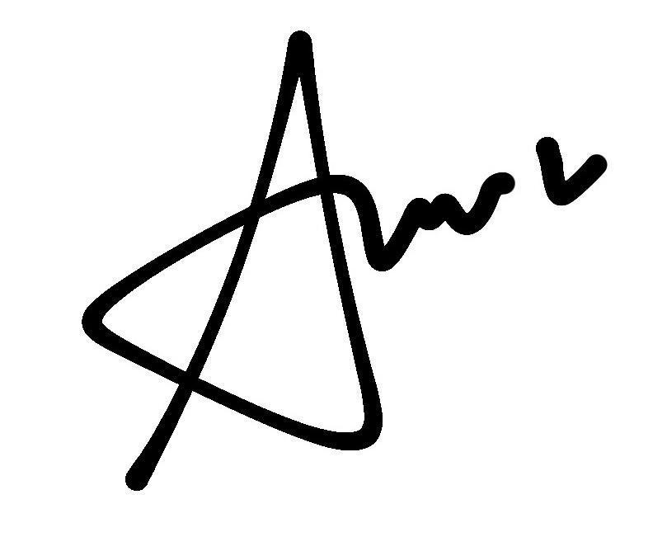

DECLARATION
The undersigned (as in the list above) fully understand that it is our sole responsibility to look after our own safety for this event. In the event of any misfortune or accidental injury involving us, whether or not due solely to personal negligence or otherwise, we hereby declare that the University shall not be held responsible. Should any other person suffer such accidental injury as a result of any act whatsoever or omission on our part, we hereby undertake full responsibility and indemnify the University against any claims made against it in relations to such accidental injury.
Notes:
- Positions can be added/removed depending on the nature of the event.
- Include the namelist of all department committees if any.
- Please note that each position is subject to approval by DSA for the purpose of USSDC soft skill points and Testimonials.
Instructor:
Ms. Chow (Multilevel yoga)🧘
Week 1&2 will be conducted in hybrid mode
MS Teams | KB111 & KB112

MS Team code: 0lbr09x
https://teams.microsoft.com/l/team/19%3AYbd-PgnQ40hribK6U8MOpHwIHSeWtqK5WAMuOxnHriQ1%40thread.tacv2/conversations
Attendance will be recorded by following method
Sign-in form: https://forms.gle/d9x6Gg29tudFPt1WA
- Participant will be filled in the form and submit for class registrations as (sign-in form)
- This form will collect all the notices informations and classes details
Sign-out form: (each week will prepare by secretary)
- Will prepare each class and attendance will be given according to the sign-out/attendance form
- This form will record participant entry and exit timestamp

4. Job Scope and Responsibilities:
Chairperson
- Highest commanding position in organizing committee
- Delegate responsibilities to the entire committee
- Checking and scanning all the document before upload
- Role of photographing
Secretary
- Prepare a proposal for the event
- Application for event venue
- Prepare documentation required by the event
Treasurer
- Prepare account statement after the event
- Record daily sales, total sales, and profit
Publicity
- On duty
- Preparation of event poster
- Publish and promote events on social media accounts (Facebook and Instagram)

5. Departmental Proposals/Plans:
5.1 Programme Department
The programme department crews will be preparing the duty slots to ensure all committee able to perform their duty. Besides, the programme department will be calculating all the sales, income, and profit during and after the selling project.
5.2 Publicity Department
The publicity department crews will prepare the contents and upload the event poster on the society media such as Facebook and Instagram. Also, they will be in charging the photographing role during the event.

Notes: Add/Remove departments based on your event needs. Responsibilities/action plans/schedule relevant to each department should be outlined.

6. Budget
BUDGET 1: GENERAL PURPOSE

Particulars | Note | Amount (RM)
INCOME
Collection of fees | N1 | 800.00
Total Income |  | 800.00
EXPENDITURE
Course fee | N2 | 1200.00
Total Expenditure |  | 1200.00
Surplus/(Deficit) to be deposited into/ (claimed from) society account |  | (400.00)
Fund Allocation from Society Account =RM250.00

N1
No | Note N1 | Details | Amount
1 | Income | Fee from participant (Approx.20 participant) | RM40*20 =RM800

N2
No | Note N2 | Details | Amount
1 | Expenditure | Instructor from outsider | RM 1200

Note: The proposed budget will need to be reflected in the income statement, and thus should reflect actual departments/expenditures for the event. Any expense incurred which is not budgeted, the justification should be provided to support it. Add references (i.e. N1-N10) to breakdown/validate large sums (above RM250.00).

Note: Requisition of cash advance is not limited for one time only.

BUDGET GUIDELINES:
- The Budget for any event should submitted (together with the proposal) at least 1 month before the event date to avoid complications/delays. DSA reserves the right to exercise discretion for approval for any submission shorter than the stipulated period.

- The withdrawal percentage of Guidelines on Clubs and Societies Fund Allocation is used as a reference. The withdrawal percentage may be adjusted as per case-by-case basis based on Clubs and Societies Annual Planning.

- The fund allocation from society fund is only confined to one or more of the following:
a. General operational use for running the society/ club in-line with the constitution of the society/club
concerned, e.g stationery, approved meeting expenses (e.g. traveling allowance from one faculty to
another), account books etc.
b. Non-profit making activities e.g. rental of venues and facilities of expenses on weekly activities, non-
profit making seminars/talks/exhibitions, recruitment etc.
c. To subsidise deficit in a revenue-generated project/activity (with valid reasons of incurring loss).
d. To subsidise members in participation e.g. transport fees for visits (amount has to be justified).
e. Food is allowed for activities involving all members, e.g. AGM.
f. Any other expenditures which are reasonable and justifiable.

- Budgets below RM1000.00 shall be approved by DSA Assistant Manager or Senior Assistant Manager, between RM1001.00 to RM5000.00 by the DSA Manager or Senior Manager, and above RM5001.00 by the DSA Head of Department.

7. Approval

Prepared By,
___________________ ___________________ ___________________
LIM SAI KEAT Tarveen Kaur A/P Jura Singh Pong En Ni
Organising Secretary Organising Treasurer Organising Chairperson
Date: 4/2/2026 Date: 4/2/2026 Date: 4/2/2026

Recommended By,


___________________
Ms Heng Sze Lu
Adviser
Yoga Society
Date: 4/2/2026

Verified By, Approved By,

___________________ ___________________
Mr Belinda Ms Choong Yee Chin
Assistant Manager/ Manager/ Senior Manager
Senior Assistant Manager Department of Student Affairs
Department of Student Affairs Date:
Date:

